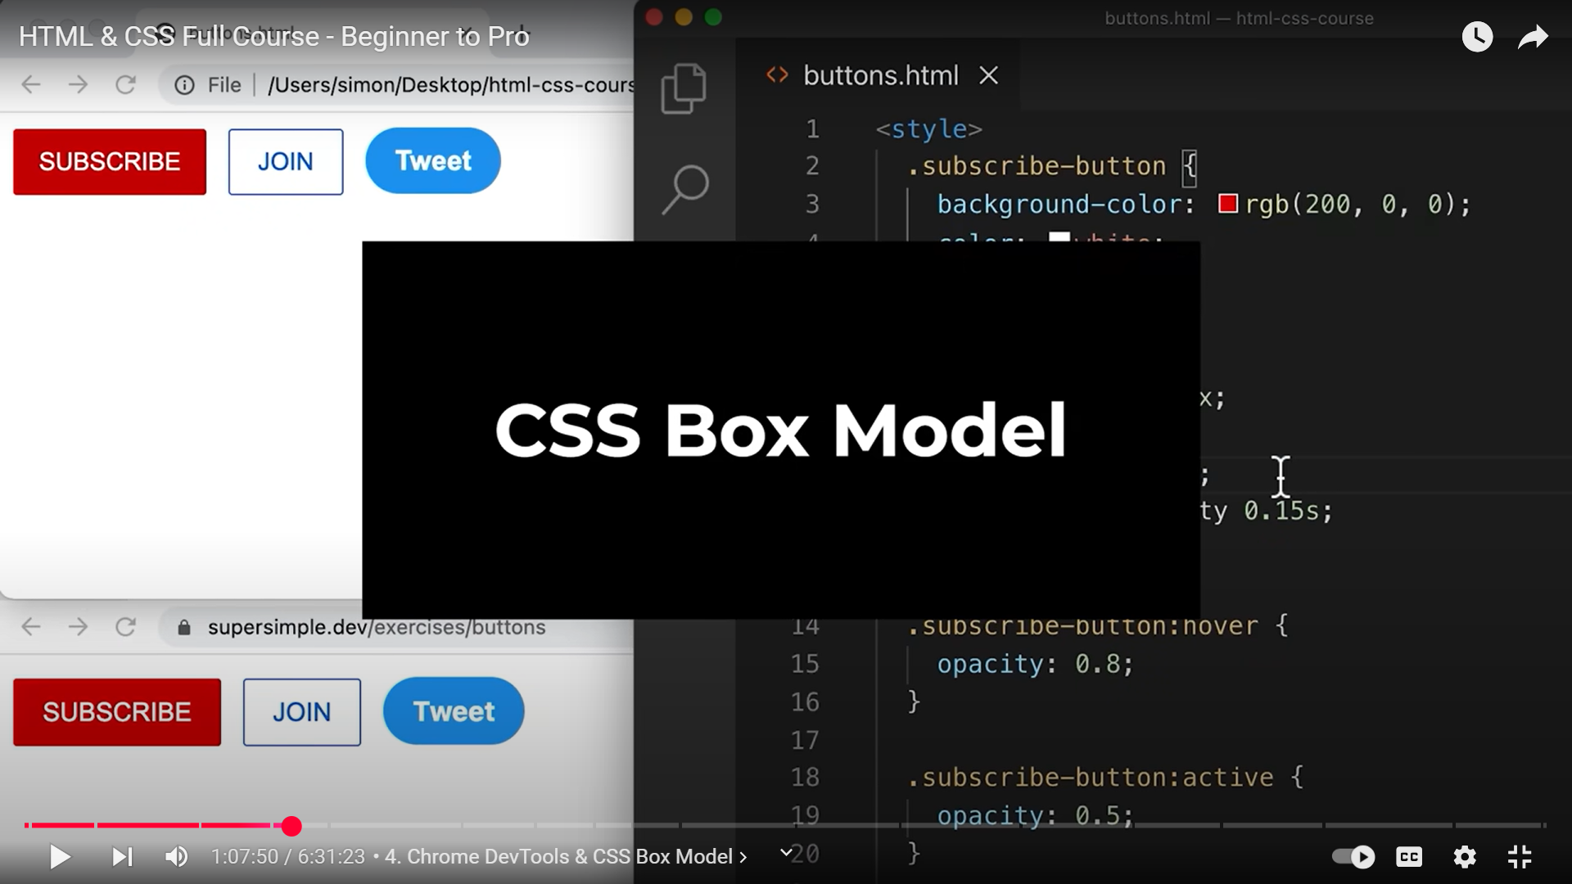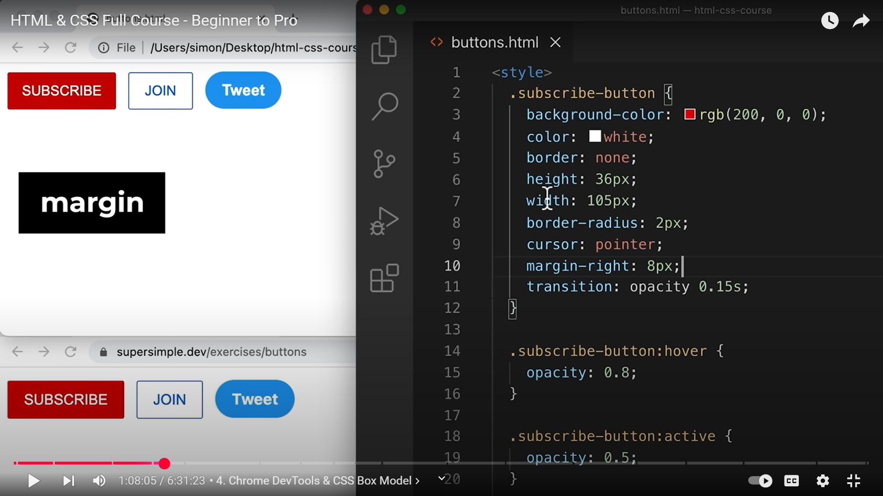  
**MARGIN IS THE SPACING OUTSIDE OF THE ELEMENTS!!!!!!!!!!!!!!!!!!!!**

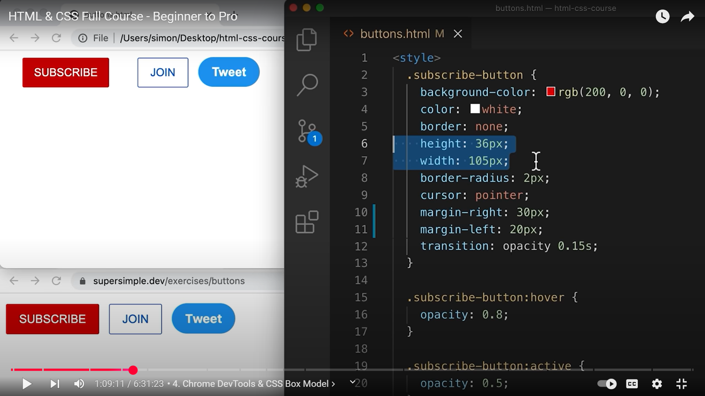 **AT 6,7 SETTING HEIGHT AND WIDTH IS NOT A GOOD IDEA**

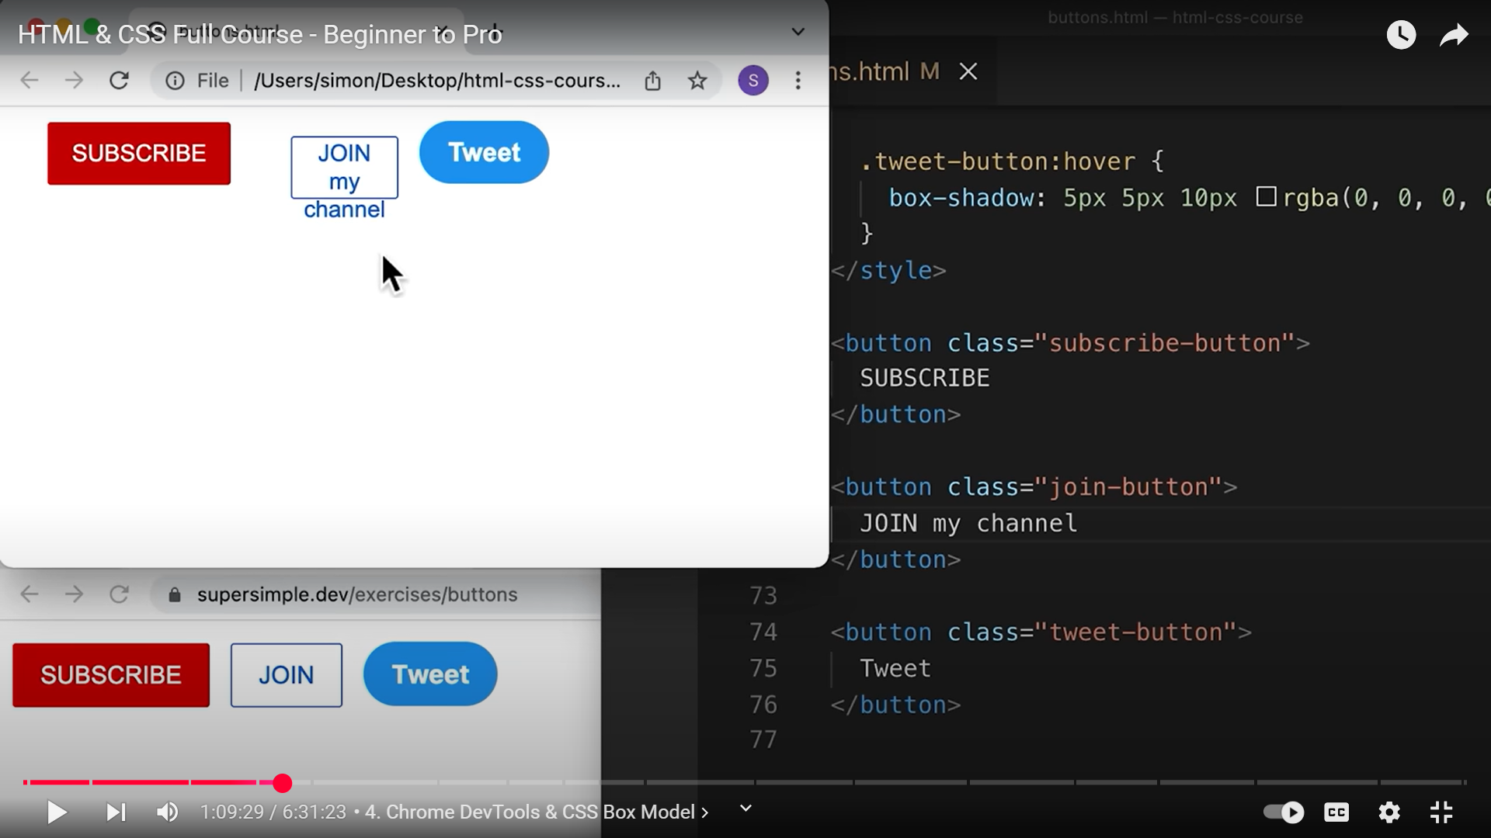 **TEXT OVERFLOWS AS WE HAVE HARDCODED HEIGHT AND WIDTH**

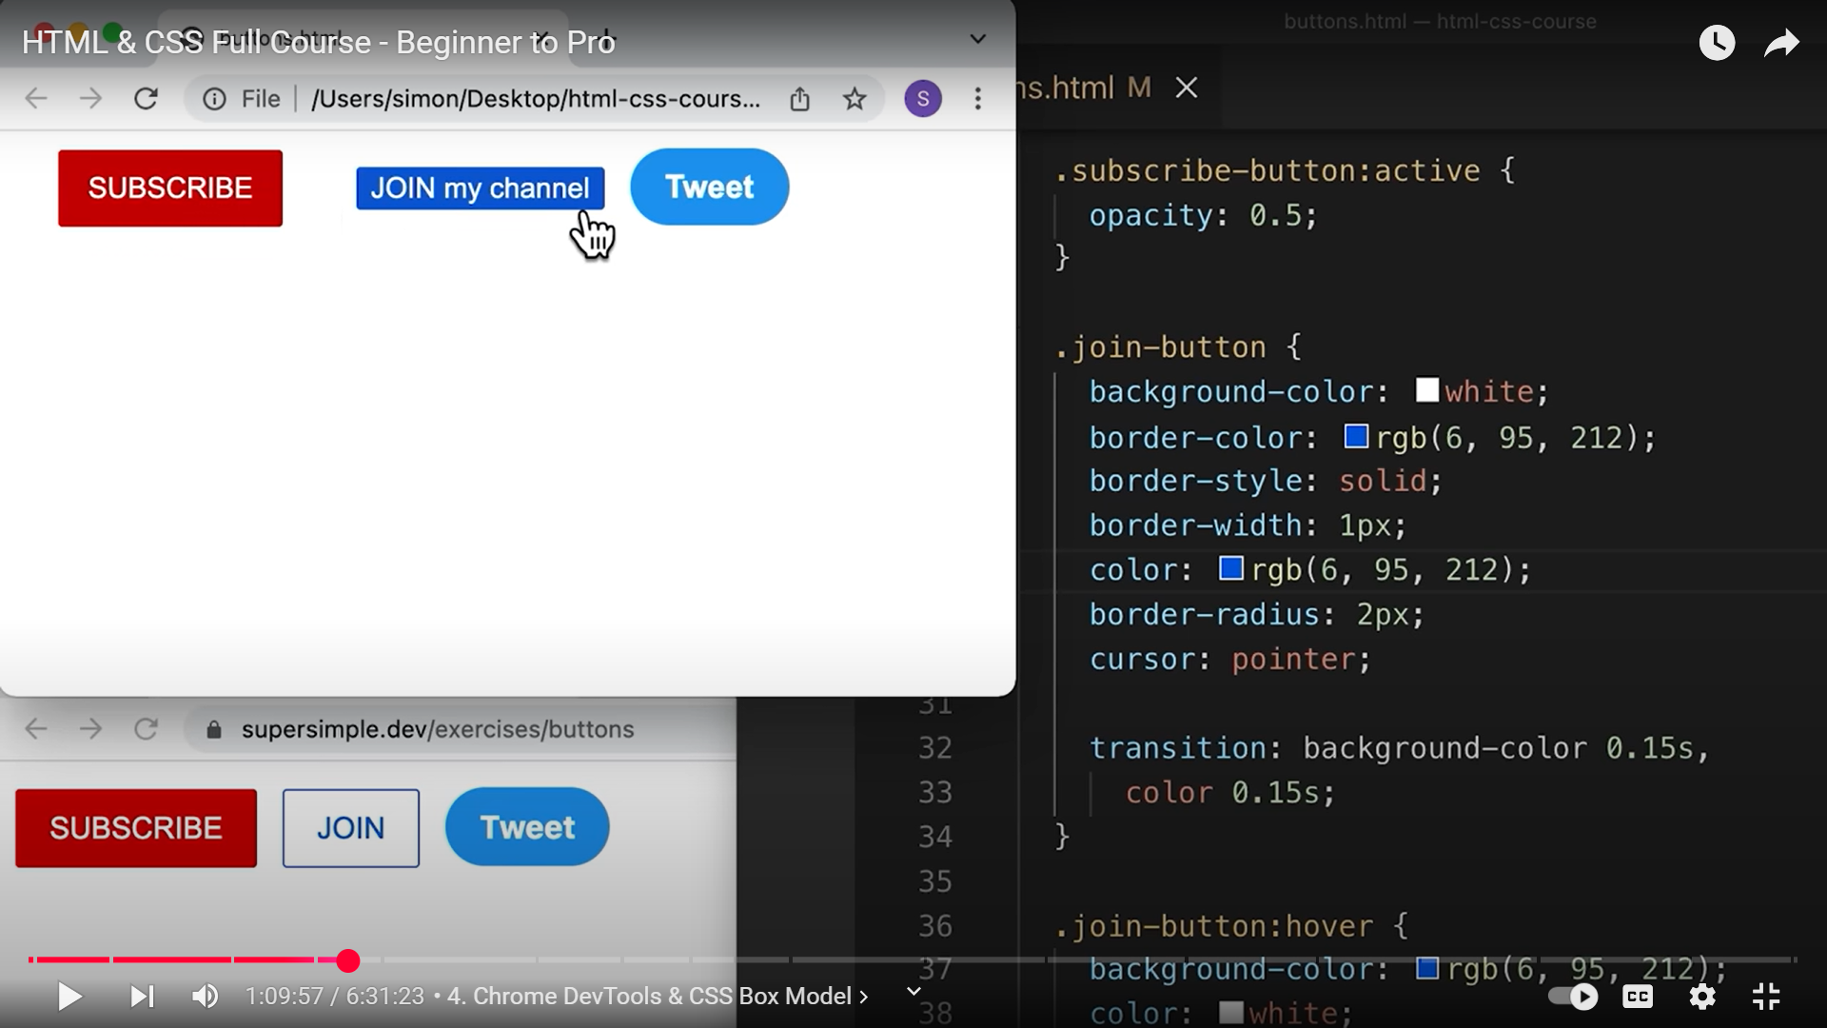**SPACING ON THE INSIDE OF THE BUTTON IS CALLED PADDING!!!!!!!!!!!!!!!!!!!!!!!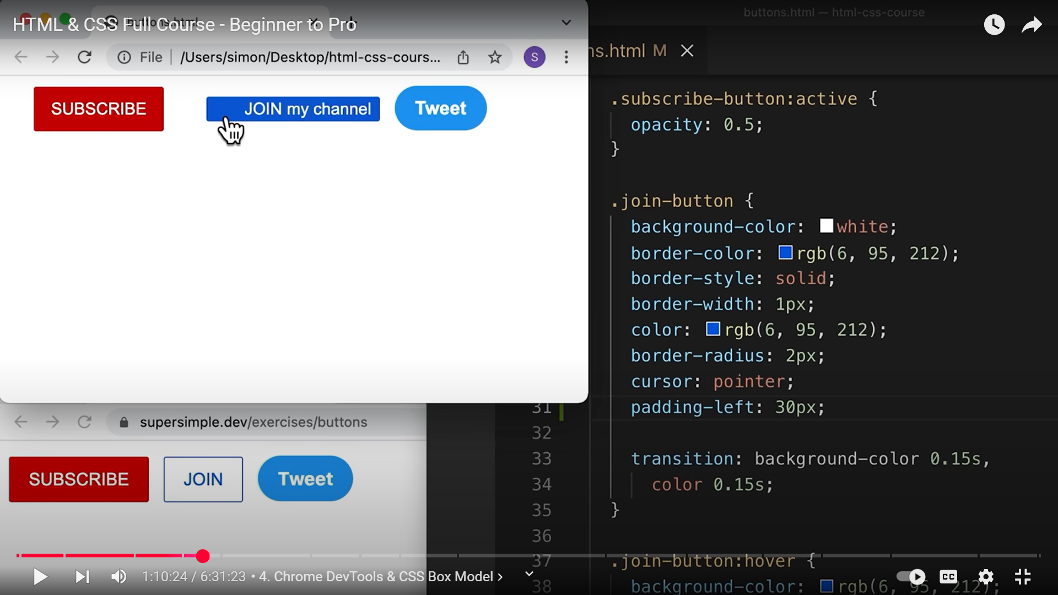31**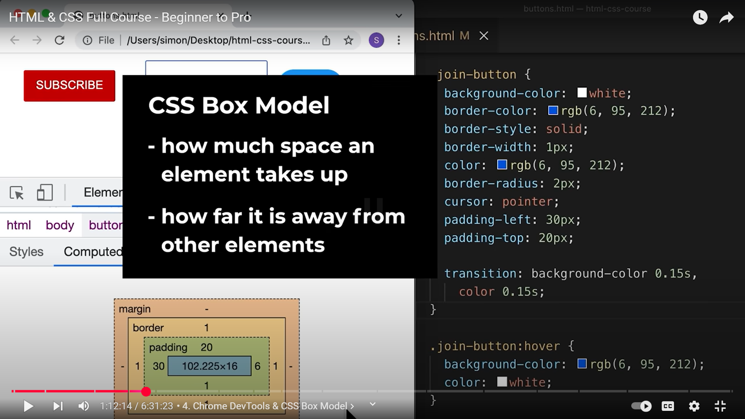

**WITH PADDING, THE TEXT WILL NOT OVERFLOW UNLIKE HEIGHT AND WIDTH!!!!!!!!!!!!!!!!!!!!!!!!!!!!!!!!!!**

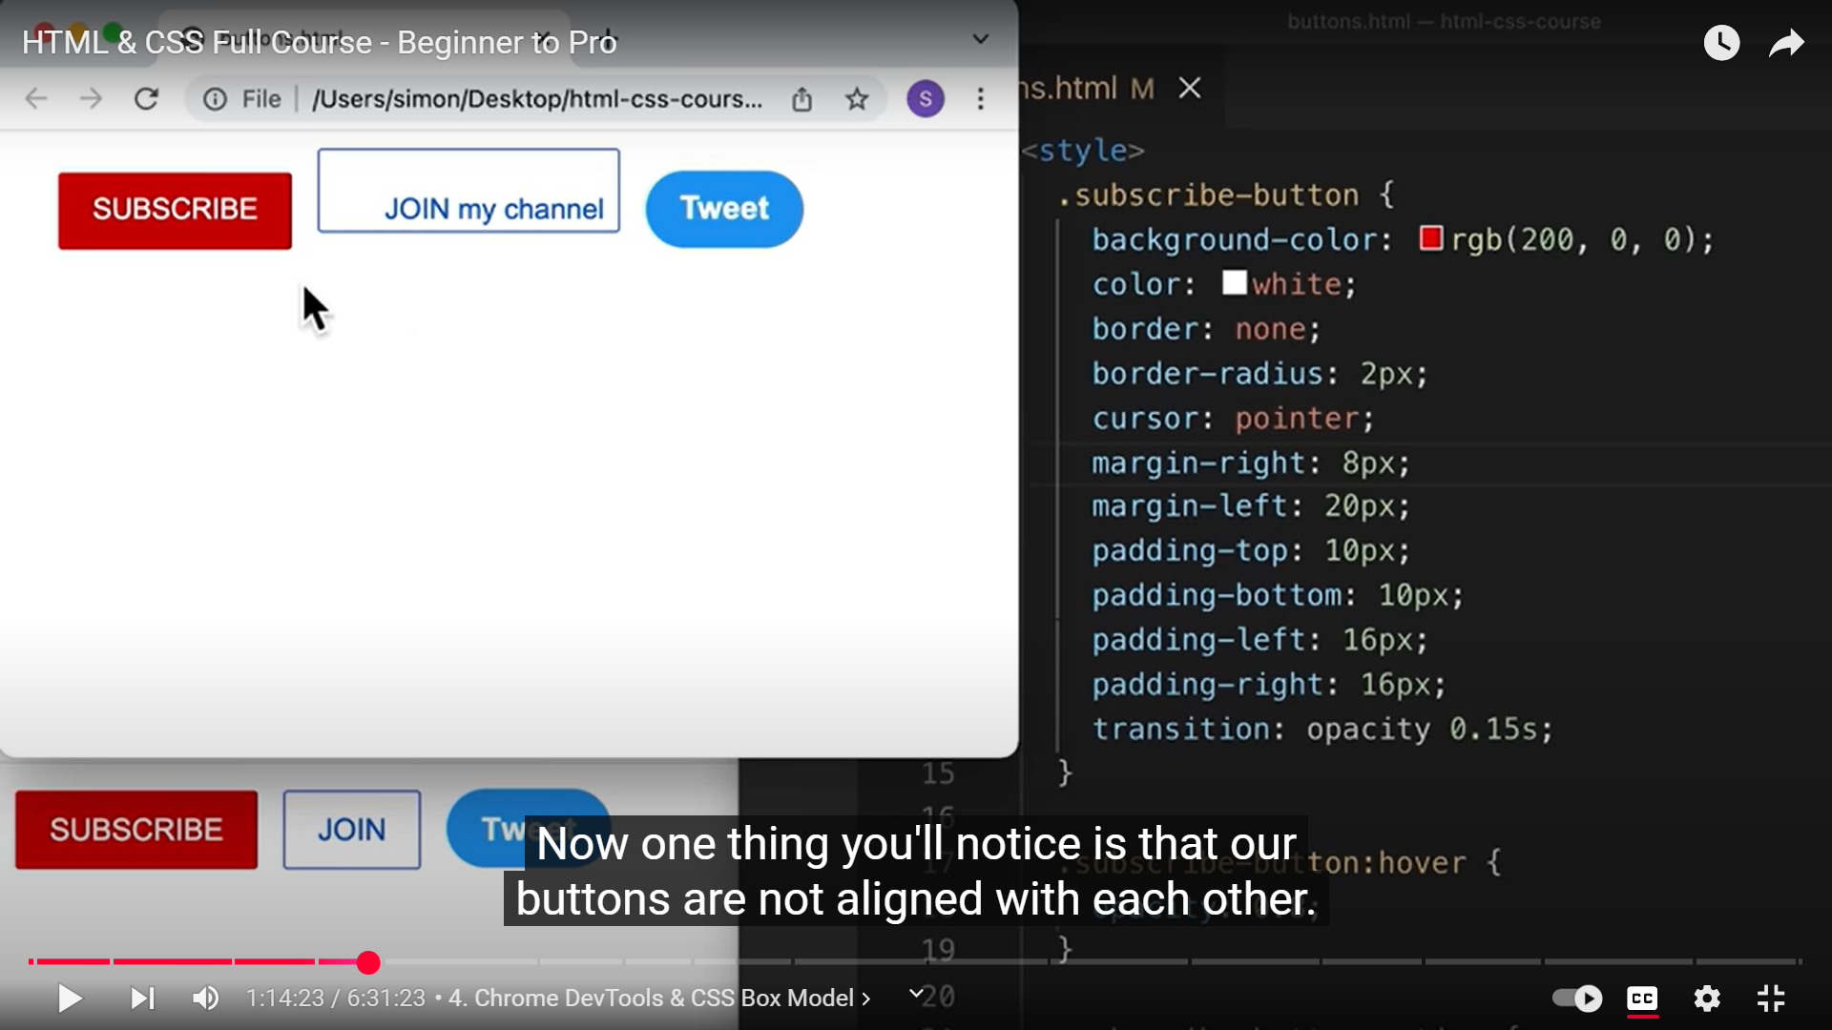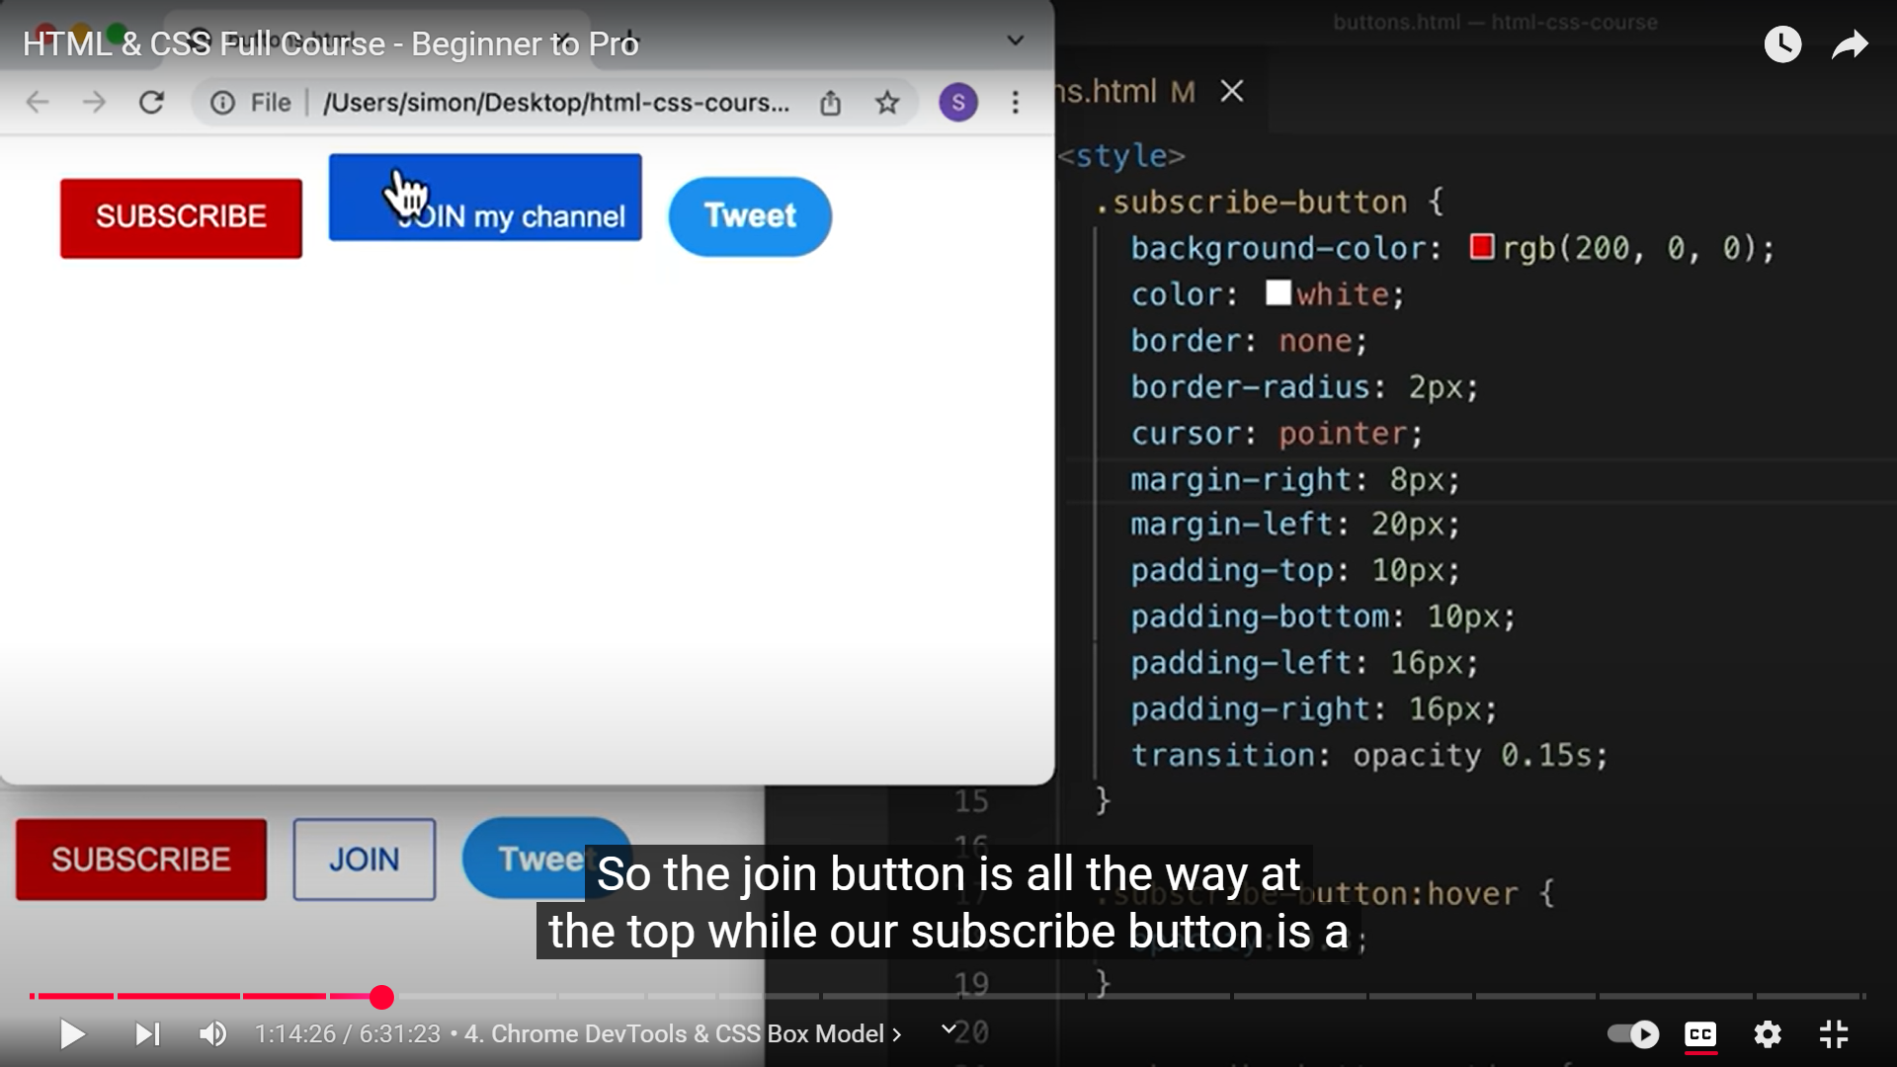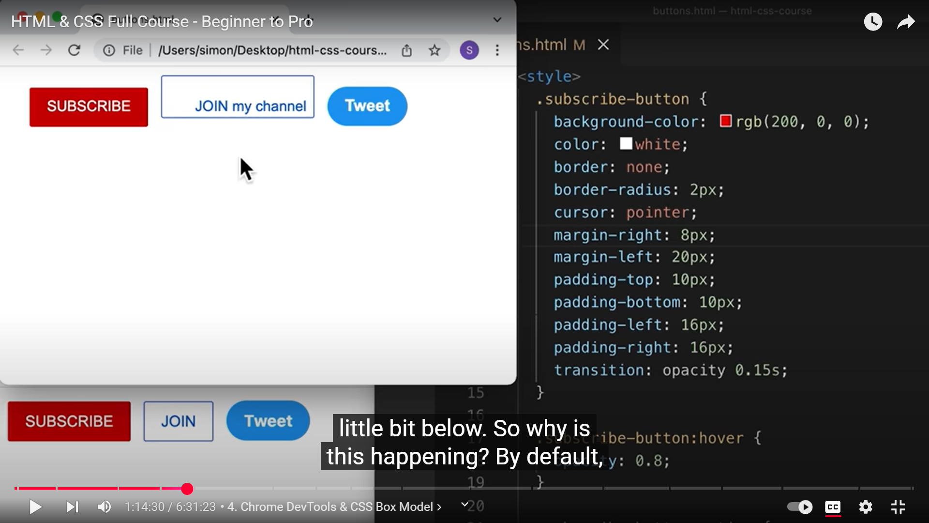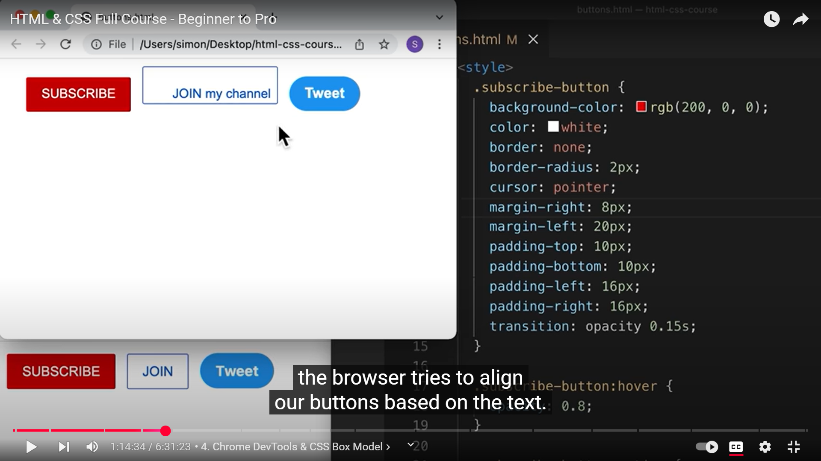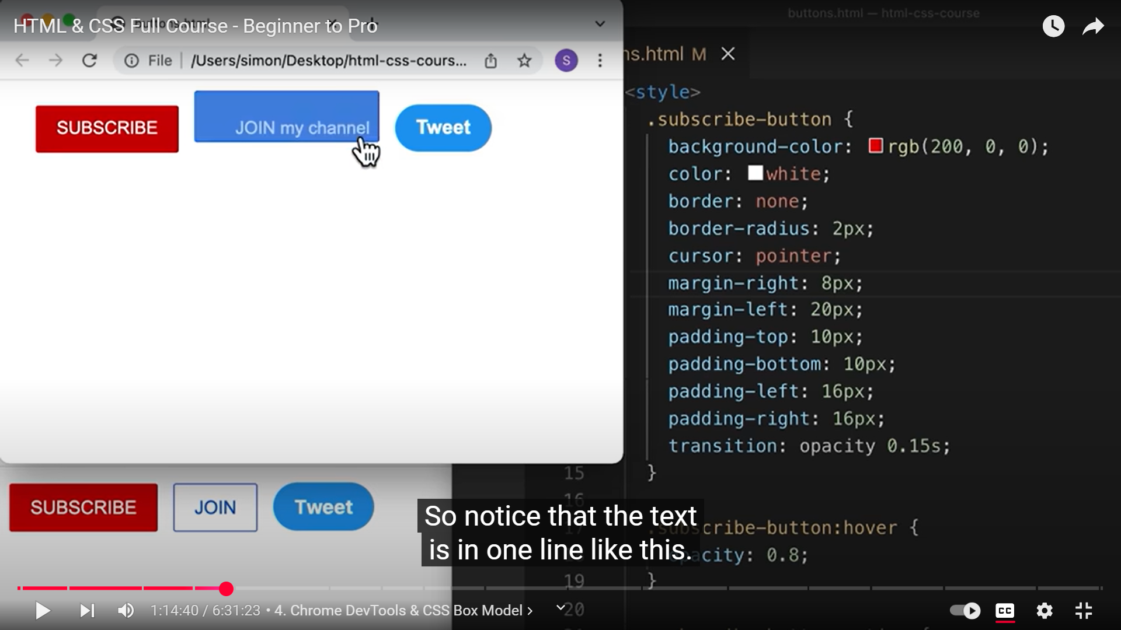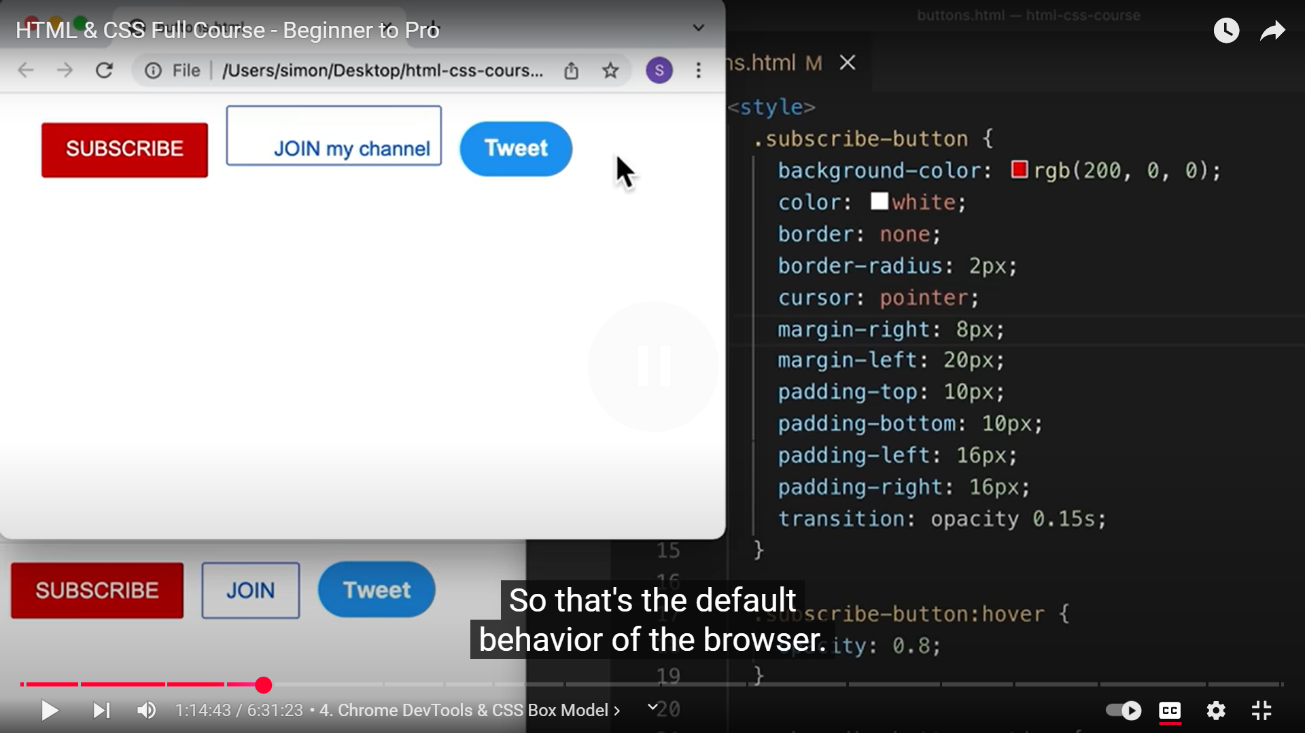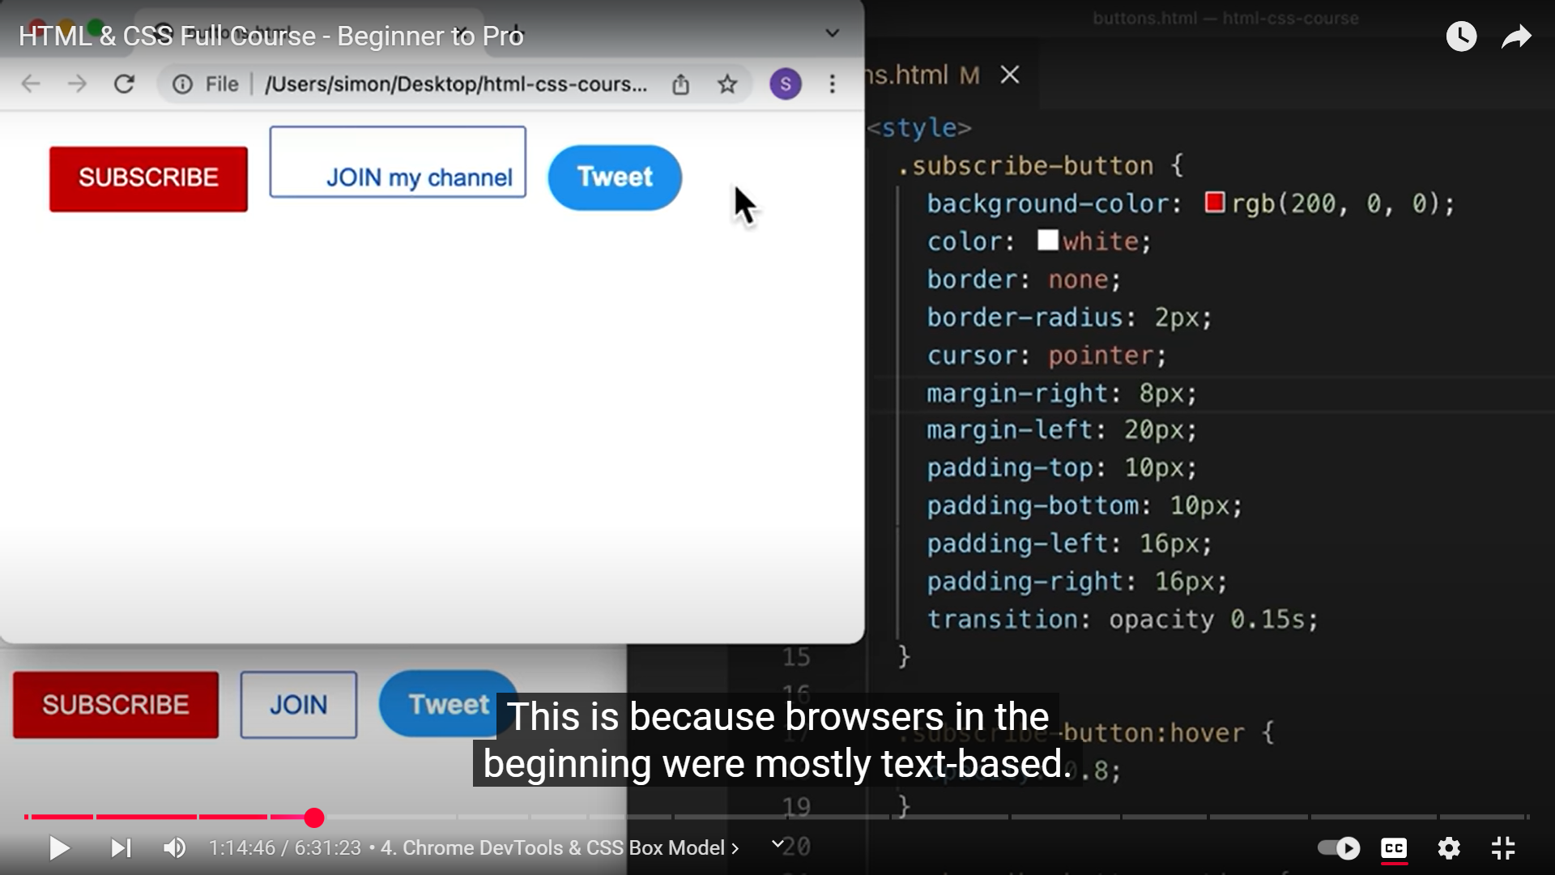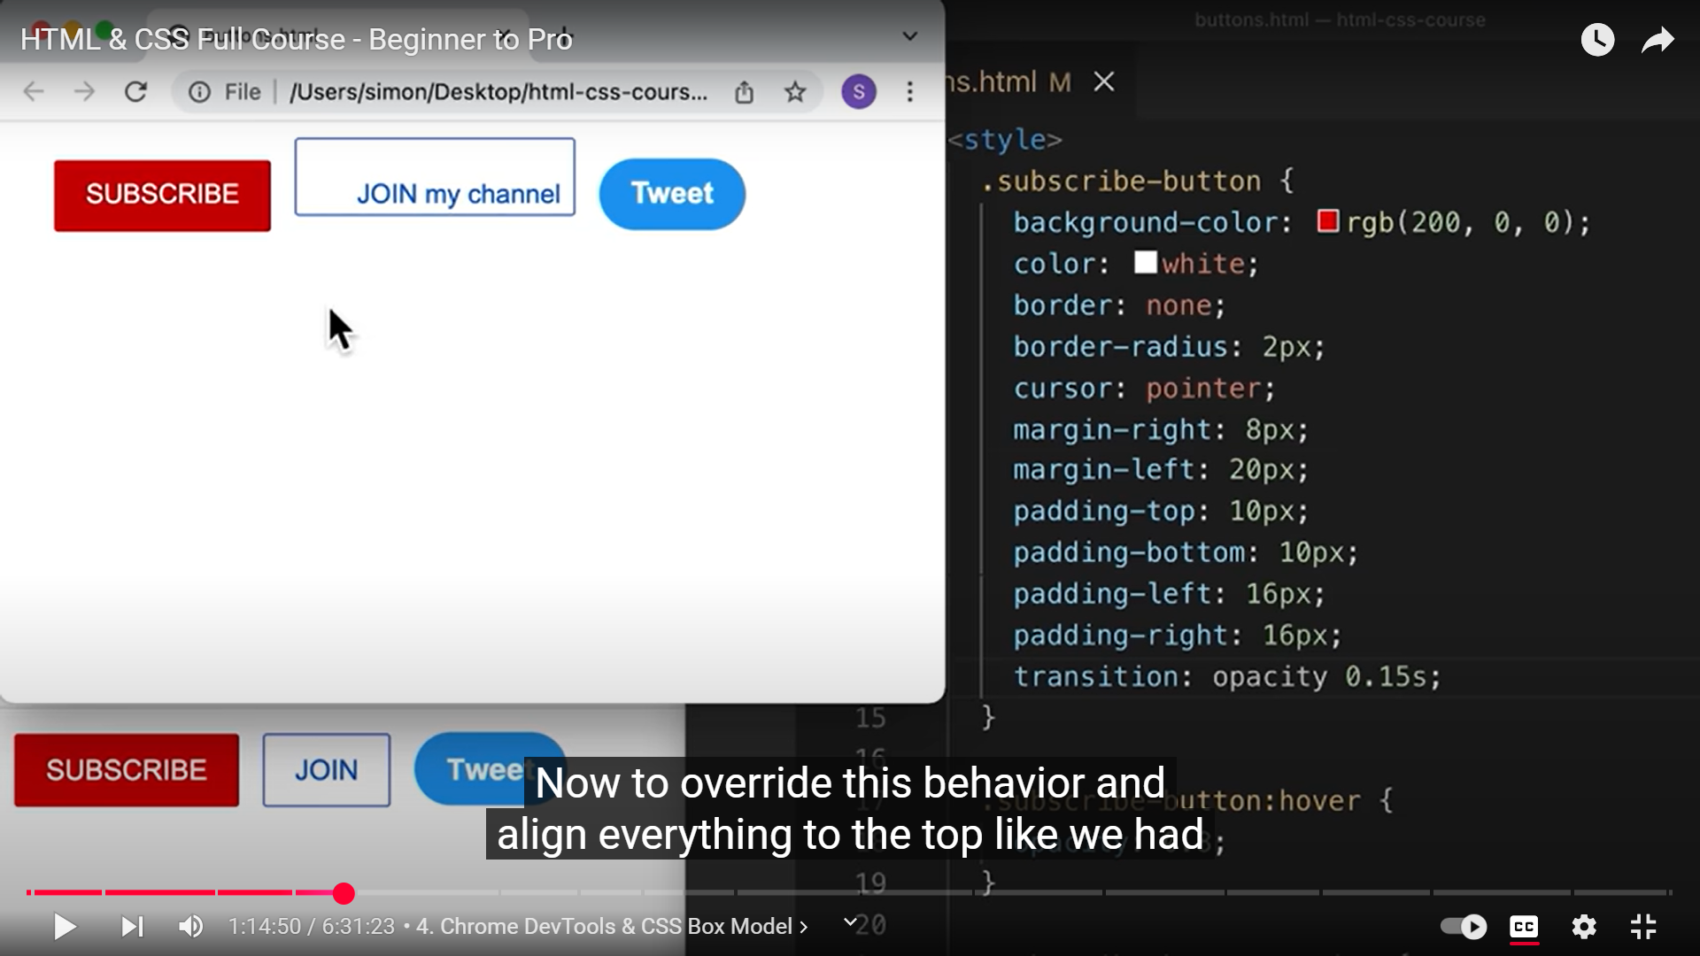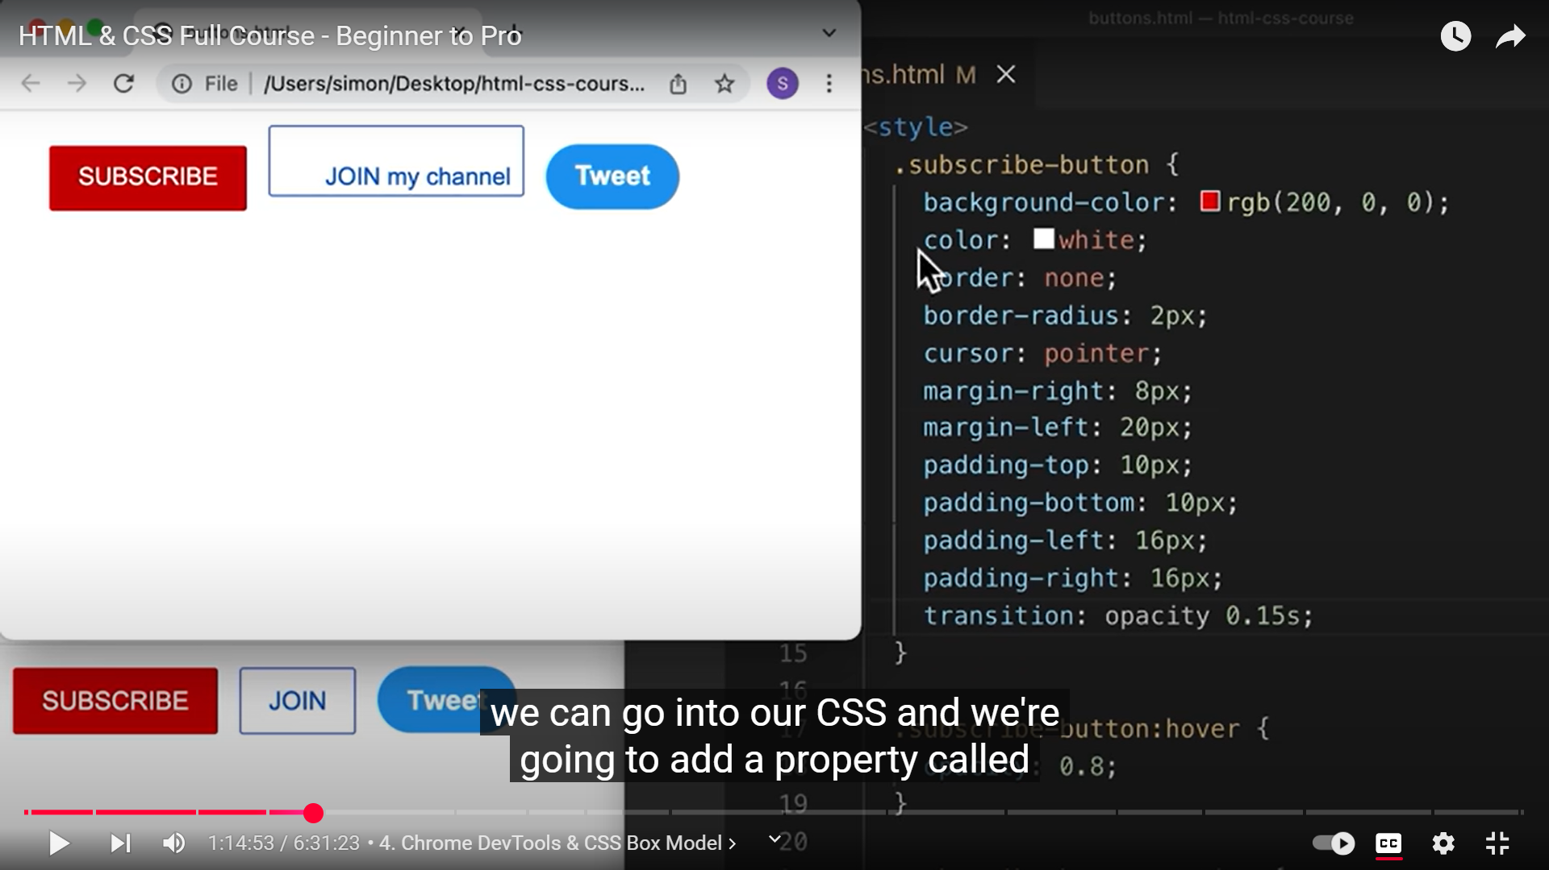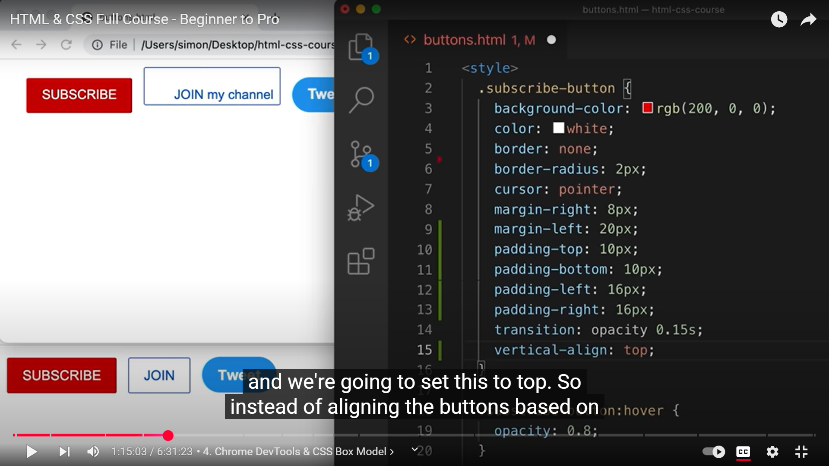 **15**

